CREWKERNE TOWN COUNCIL
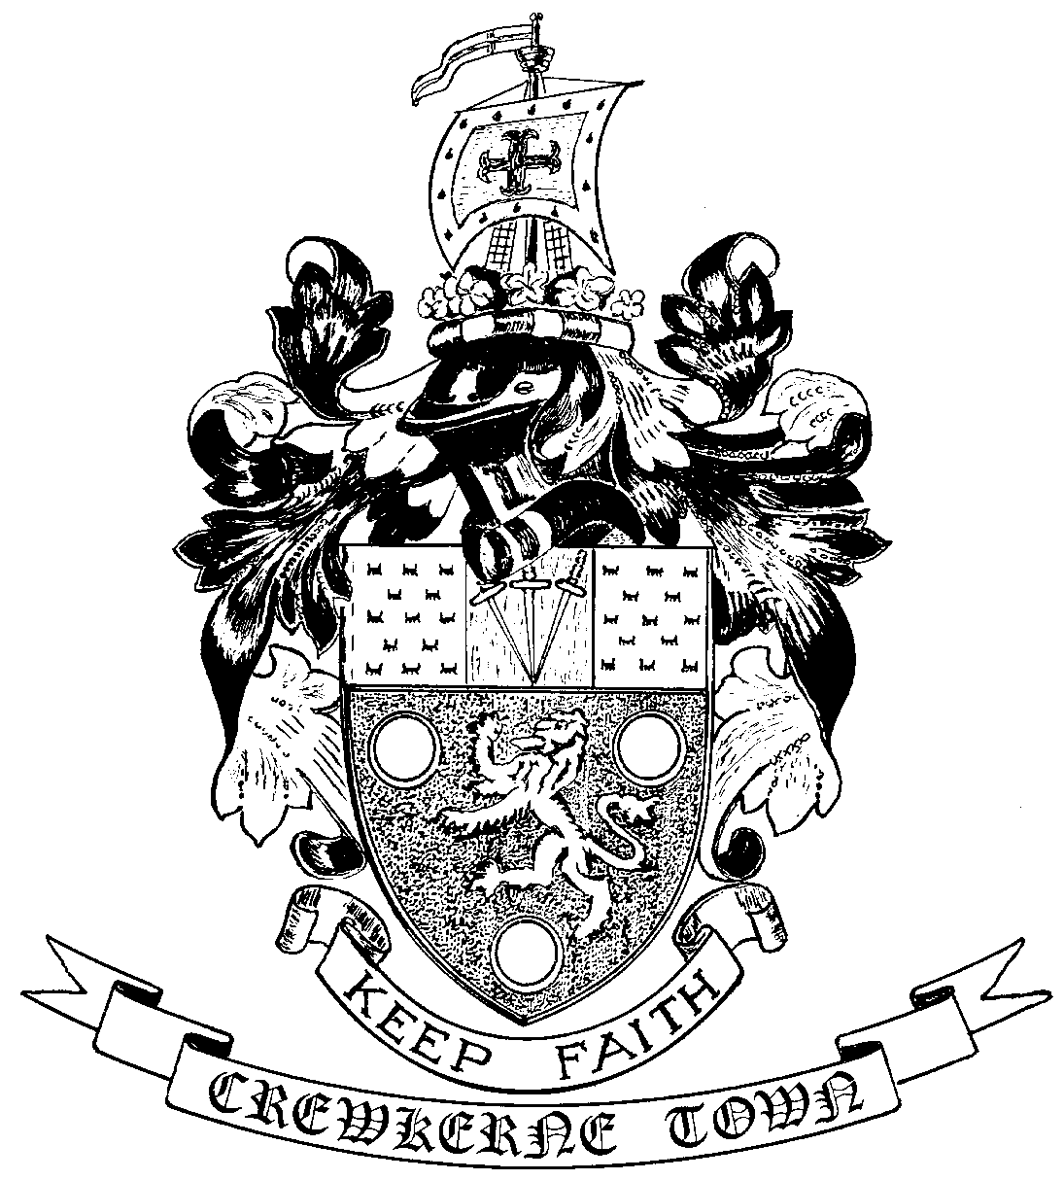

TOWN HALL
MARKET SQUARE
CREWKERNE
SOMERSET TA18 7LN
TEL: 01460 74001
Email: towncouncil@crewkerne-tc.gov.uk

Councillors are hereby summoned and members of the press and public are invited to attend the next meeting of Crewkerne Town Council, to be held in the Council Chambers, Market Square on Monday 25 September 2017 at 6.45 pm.

……………………..
Peter Davidson, Town Clerk
19 September 2017
A G E N D A

- To note apologies for absence
- Presentation from South Somerset Community Energy on the potential application of solar panels to the GRC and Aqua Centre buildings.
- Open Forum: Questions may be put to the Council during this Public Participation Session of up to 15 minutes and a maximum of 3 minutes per person.
- To confirm the minutes of the Town Council Meetings held on 24 July 2017, 14 August 2017 and 11 September 2017.
- Declarations of interest in items on the agenda.
- To receive reports from the County and District Councillors.
- Clerk’s progress report: to receive an update report (for information).
- Finance
- To approve the accounts for payment for August and September as listed
- To report the bank reconciliation for August has been completed.
- To note that the annual review of insurance cover has been undertaken.
- Zebra crossing at the top of Hermitage Street: to consider whether the Council wishes to reaffirm its support to the Highways Small Improvement Scheme which consists of the addition of a zebra crossing on Hermitage Street adjacent to the mini roundabout.
- Request from the Henhayes Centre for parking: to consider further the request from the Henhayes Centre to allow short term parking on the Aqua Centre bus stop on Henhayes car park.
- Electoral review of South Somerset & warding arrangements: to consider whether the Council wishes to provide a response to the consultation.
- Rents and Hire Charges: to approve the recommendations of the September 2017 Amenities Committee meeting for the rents and hire charges for 2018/19.
- Weekly market: to note that the weekly market “summer promotion” concludes at the end of September and to reconsider the question of the closure of Market Square.
- Approval of overtime payments: to approve the overtime for the Cemetery Superintendent for his support to the cemetery Open Day and for the groundsman who supported the CUDOS event in the Victoria Hall.
- Bus services: Cllr Best to report on the recent changes to the bus service.

- To receive draft Committee and Working Group minutes:
- Planning and Highways Committee meeting held on 11 September 2017
- Amenities Committee meeting held on 11 September 2017
- Town Council Surgeries: for 18 November, 16 December and 20 January 2018. Two Councillors required to undertake each session.
- Outside Bodies: to receive a report for CSYAL.
- To receive Matters of Report (for information only)
- Next meeting on Monday 23 October 2017 at 6.45pm in the Council Chamber.

In accordance with the Public Bodies (Admission to Meetings) Act 1960 s 1(2), to resolve that the press and members of the public be excluded from following items having regard to the confidential issues to be discussed
Confidential Session Exclusion of the Press & Public - Contractual Matter

