CREWKERNE TOWN COUNCIL
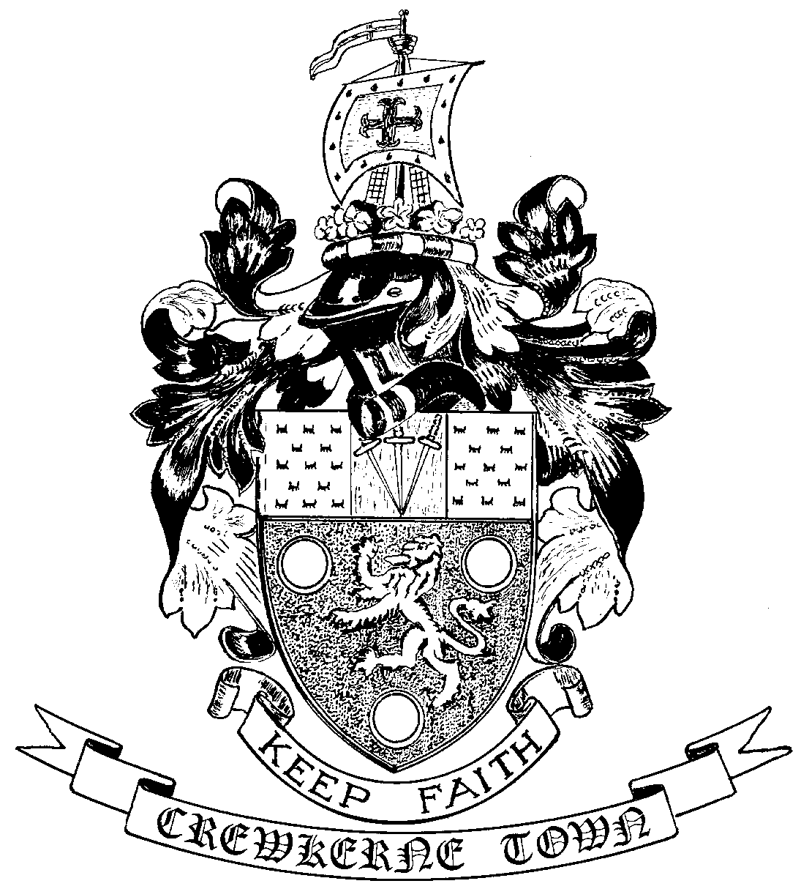

TOWN HALL
MARKET SQUARE
CREWKERNE
SOMERSET TA18 7LN
TEL: 01460 74001
Email: towncouncil@crewkerne-tc.gov.uk

Councillors are hereby summoned and members of the press and public are invited to attend the next meeting of Crewkerne Town Council, to be held in the Council Chambers, Market Square on Monday 27 November 2017 at 6.45 pm.

……………………..
Peter Davidson, Town Clerk
21 November 2017
A G E N D A

- To note apologies for absence
- Open Forum: Questions may be put to the Council during this Public Participation Session of up to 15 minutes and a maximum of 3 minutes per person.
- To confirm the minutes of the Town Council Meeting held on 23 October 2017.
- Declarations of interest in items on the agenda.
- To receive reports from the County and District Councillors.
- Clerk’s progress report: to receive an update report (for information).
- Finance
- To approve the accounts for payment for November as listed
- To report the bank reconciliation for October has been completed.
- Updated Financial Regulations: for approval.
- Aqua Centre rent: to note that the rent for the Aqua Centre is due for review and to consider the process to be adopted for such a review.
- SSDC Local Plan Issues and Options Consultation: to consider how the consultation paper should be reviewed and a Town Council response compiled.
- Severalls tennis courts: to consider whether the Council supports the principle of retaining the tennis courts as a facility and to agree the next steps.
- CTC social media: to consider whether the Town Council should have its own social media presence.
- Use of Henhayes: to consider the request from Crewkerne Rugby Club for the use of Henhayes for a local schools-organised rugby tournament on Wednesday 21 March 2018.
- To receive draft Committee and Working Group minutes:
a) Planning and Highways Committee meeting held on 13 November 2017
b) Amenities Committee meeting held on 13 November 2017
- Outside Bodies: to receive reports for Chubbs Almshouses and CAD.
- Annual Meeting of Electors: to be held on Monday 16 April 2018.
- To receive Matters of Report (for information only)
- Next meeting on Monday 18 December 2017 in the Council Chamber.
In accordance with the Public Bodies (Admission to Meetings) Act 1960 s 1(2), to resolve that the press and members of the public be excluded from following items having regard to the confidential issues to be discussed.
Confidential Session Exclusion of the Press & Public - Contractual Matter

