CREWKERNE TOWN COUNCIL
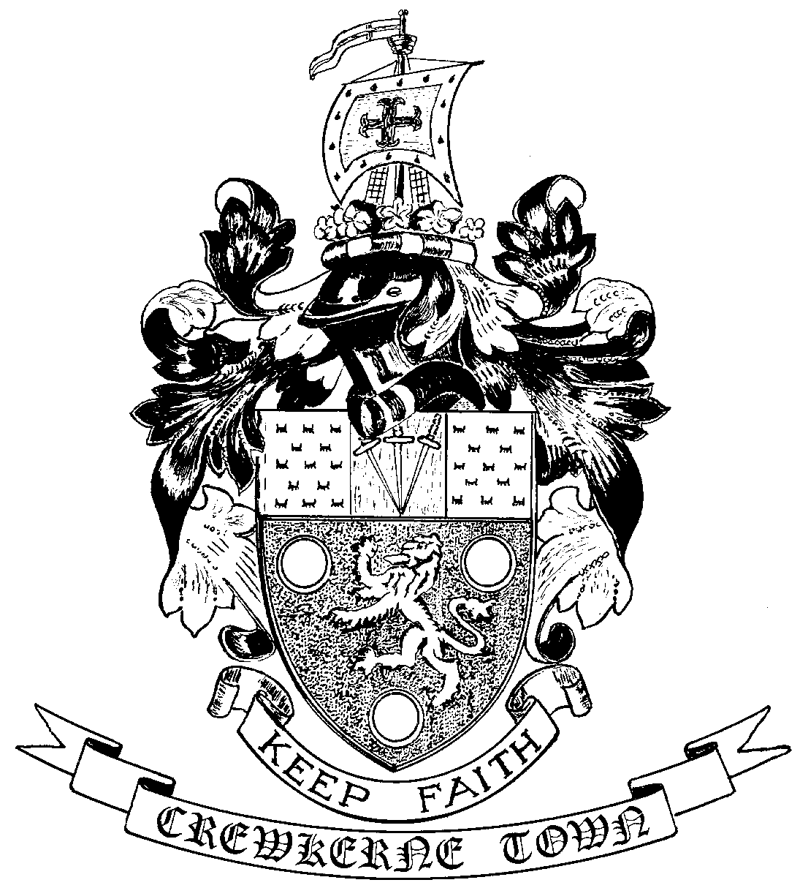

TOWN HALL
MARKET SQUARE
CREWKERNE
SOMERSET TA18 7LN
TEL: 01460 74001
Email: towncouncil@crewkerne-tc.gov.uk

Councillors are hereby summoned and members of the press and public are invited to attend the Annual Meeting of the War Memorial Commemoration Trust on Monday 25 June 2018 at 6.45pm in the Council Chamber, Market Square, to be followed immediately by the next meeting of Crewkerne Town Council.

……………………..
Peter Davidson, Town Clerk
19 June 2018

WAR MEMORIAL COMMEMORATION TRUST - ANNUAL MEETING

AGENDA

- To note apologies for absence.
2. To confirm the minutes of the previous meeting on Monday 26 June 2017
3. Approval of the audited Annual Accounts for the year ending 31 March 2018
4. Matters of report

RECONVENE AS FULL COUNCIL

- To note apologies for absence
- Open Forum: Questions may be put to the Council during this Public Participation Session of up to 15 minutes and a maximum of 3 minutes per person.
- To confirm the minutes of the Annual Meeting of Crewkerne Town Council held on 21 May 2018 and the minutes of the Town Council Meeting held on 11 June 2018.
- Declarations of interest in items on the agenda.
- To receive reports from the County and District Councillors.
- Clerk’s progress report: to receive an update report (for information).
- Finance
- To approve the accounts for payment for June as listed
- To report the bank reconciliation for May has been completed.
- Weekend Overtime: to consider the request from the Deputy Clerk that the 11 hours worked by her on the day of the Henhayes Fete be paid as overtime rather than time in lieu.
- Severalls tennis courts working group: to receive a report from Cllr. Bradly and to consider the recommendations contained therein.
- Request for a reading venue in the Town Hall: to consider the request from the charity Read Easy Bridport for the use of a room in the Town Hall as a reading venue.
- Wadham School community event: to consider the request from Wadham school for the use of Bincombe Beeches in support of a community event.
- Chairman’s Award: to consider possible nominations for the Somerset County Council “Chairman’s Award for Service to the Community 2018”.
- Junior project: to consider supporting a small project initiative put forward by a group of children.
- To receive draft Committee and Working Group minutes:
- Planning and Highways Committee meeting held on 11 June 2018
- Policy and Resources Committee meeting held on 11 June 2018
- Crewkerne & West Crewkerne Joint Burial Committee meeting held on 5 June 2018
- Outside Bodies: to receive reports for Birds Almshouses and CAD.
- To receive Matters of Report (for information only)
- Next meeting on Monday 30 July 2018 at 6.45pm in the Council Chamber.

In accordance with the Public Bodies (Admission to Meetings) Act 1960 s 1(2), to resolve that the press and members of the public be excluded from following items having regard to the confidential issues to be discussed.
Confidential Session: Exclusion of the Press & Public - Staffing and Contractual Matters

