CREWKERNE TOWN COUNCIL
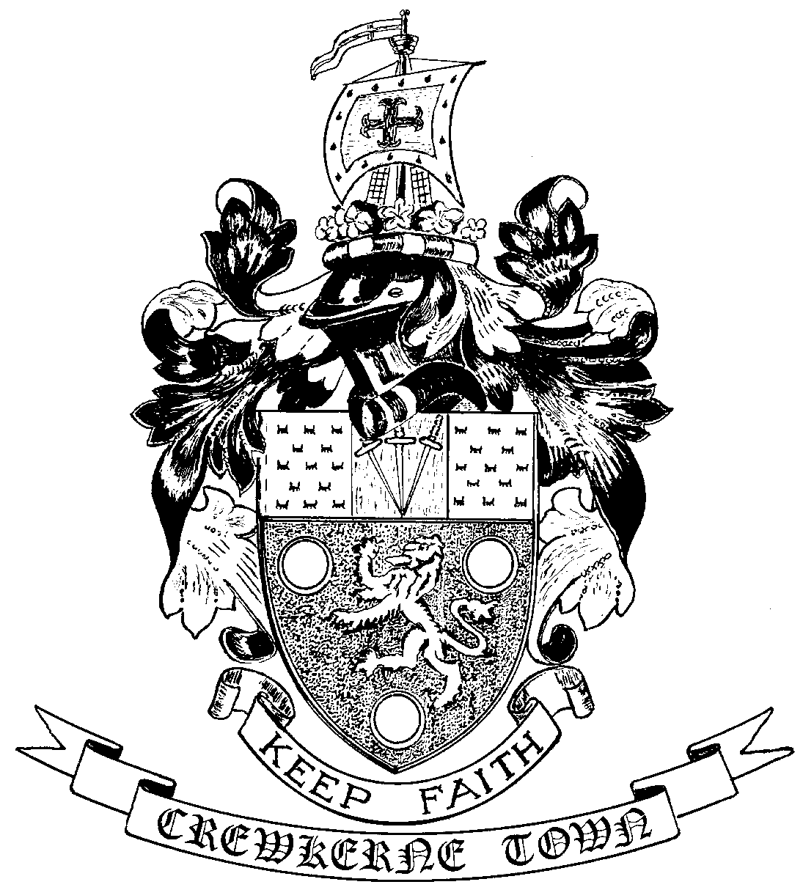

TOWN HALL
MARKET SQUARE
CREWKERNE
SOMERSET TA18 7LN
TEL: 01460 74001
Email: towncouncil@crewkerne-tc.gov.uk

To all Members of the Council
Councillors are hereby summoned and members of the press and public are invited to attend the next meeting of Crewkerne Town Council, to be held in the Council Chamber, Market Square on Monday 29 October 2018 after the Policy and Resources Committee meeting and commencing not before 7pm.

……………………..
Peter Davidson, Town Clerk
23 October 2018
A G E N D A

- To note apologies for absence
- Open Forum: Questions may be put to the Council during this Public Participation Session of up to 15 minutes and a maximum of 3 minutes per person.
- To confirm the minutes of the Town Council Meeting held on 24 September and 15 October 2018.
- Declarations of interest in items on the agenda.
- To receive reports from the County and District Councillors.
- Clerk’s progress report: to receive an update report (for information).
- Finance
- To approve the accounts for payment for October as listed
- To report the bank reconciliation for September has been completed.
- S106 leisure planning contributions: to consider the potential applications for the S106 contributions associated with planning application 18/02363/FUL (North Street trading estate).
- Installation of Christmas lights: to consider the quotation received for installation of Christmas lights in Market Street.
- Town Council website and email provision: to consider the proposal from Cllr. Miss Pritchard for alternative website and email provision for the Council.
- Advertising display equipment for the LIC: to consider the provision of match funding to a proposed grant application to the Market Towns Investment Group, for advertising display for the LIC.
- Request for the use of the bus parking area on Henhayes: to consider a request from Crewkerne Farmers Market for the use of the Henhayes bus parking area.
- Quarterly newsletter: to approve the content of the newsletter.
- To receive draft Committee and Working Group minutes:
- Planning and Highways Committee meeting held on 15 October 2018.
- Joint Burial Committee meeting held on 9 October 2018.
- Town Council Surgeries: for 15 December and 19 January 2019. Two Councillors required to undertake each session.
- Outside Bodies: to receive reports for Birds Almshouses and CAD.
- To receive Matters of Report (for information only).
- Next meeting on Monday 26 November 2018 at 6.45pm in the Council Chamber.

