CREWKERNE TOWN COUNCIL
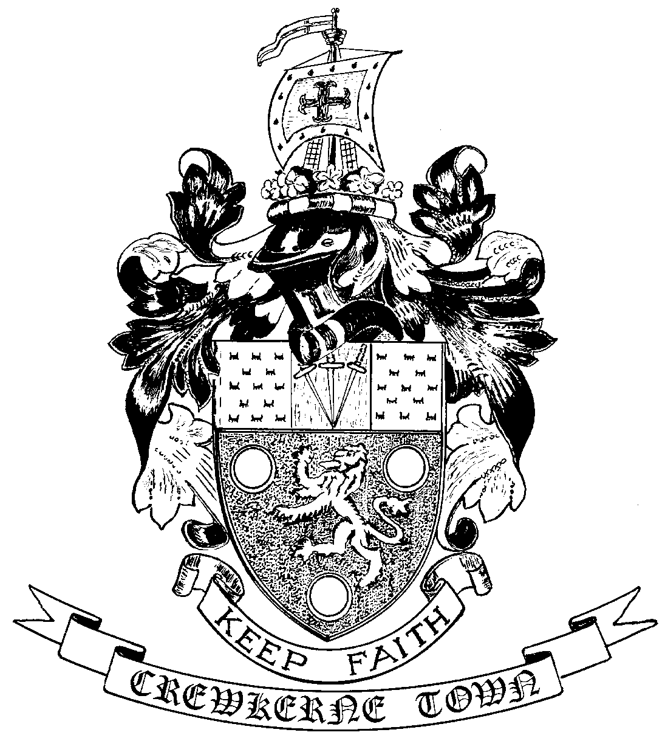

TOWN HALL
MARKET SQUARE
CREWKERNE
SOMERSET TA18 7LN
TEL: 01460 74001
Email: towncouncil@crewkerne-tc.gov.uk

Councillors are hereby summoned and members of the press and public are invited to attend the next meeting of Crewkerne Town Council, to be held in the Council Chambers, Market Square on Monday 27 February 2017 at 6.45 pm.

……………………..
Peter Davidson, Town Clerk
21 February 2017
A G E N D A

- To note apologies for absence
- Open Forum: Questions may be put to the Council during this Public Participation Session of up to 15 minutes and a maximum of 3 minutes per person.
- To confirm the minutes of the Town Council Meetings held on 23 January 2017 and 13 February 2017.
- Declarations of interest in items on the agenda.
- To receive reports from the County and District Councillors.
- Clerk’s progress report: to receive an update report (for information).
- Deferred items
- Outside Body representation: to appoint a new Town Council representative for the Crewkerne Area Business Chamber. Deferred from Jan 2017 Full Council meeting.
- Finance
- To approve the accounts for payment for February as listed.
- To report the bank reconciliation for January 2017 has been completed.
- Internal audit interim report: to receive the report from the internal auditor.
- Drainage improvements to the Henhayes field: to authorise the groundworks necessary to improve surface water drainage at Henhayes.
- Grant applications policy: to consider the draft “simplified” grant applications policy.
- Local Council Award Scheme: to confirm that the required documents, information and conditions are in place to support the submission for accreditation at “Quality Award” level.
- Annual Town Meeting of Electors: to receive the draft agenda and to consider the draft Annual Report.
- Citizen “commendation”: to consider extending the Honoured Citizen scheme to include commendations.
- Programme of Council and Committee meetings for 2017/18: to consider the draft programme of meetings.
- To receive draft Committee and Working Group minutes:
- Planning and Highways Committee meeting held on 13 February 2017.
- Policy & Resources Committee meeting held on 13 February 2017.

- Outside Bodies: to receive a report for CAD.
- To receive Matters of Report (for information only)
- Next meeting on Monday 27 March 2017 at 6.45pm in the Council Chamber.

