CREWKERNE TOWN COUNCIL
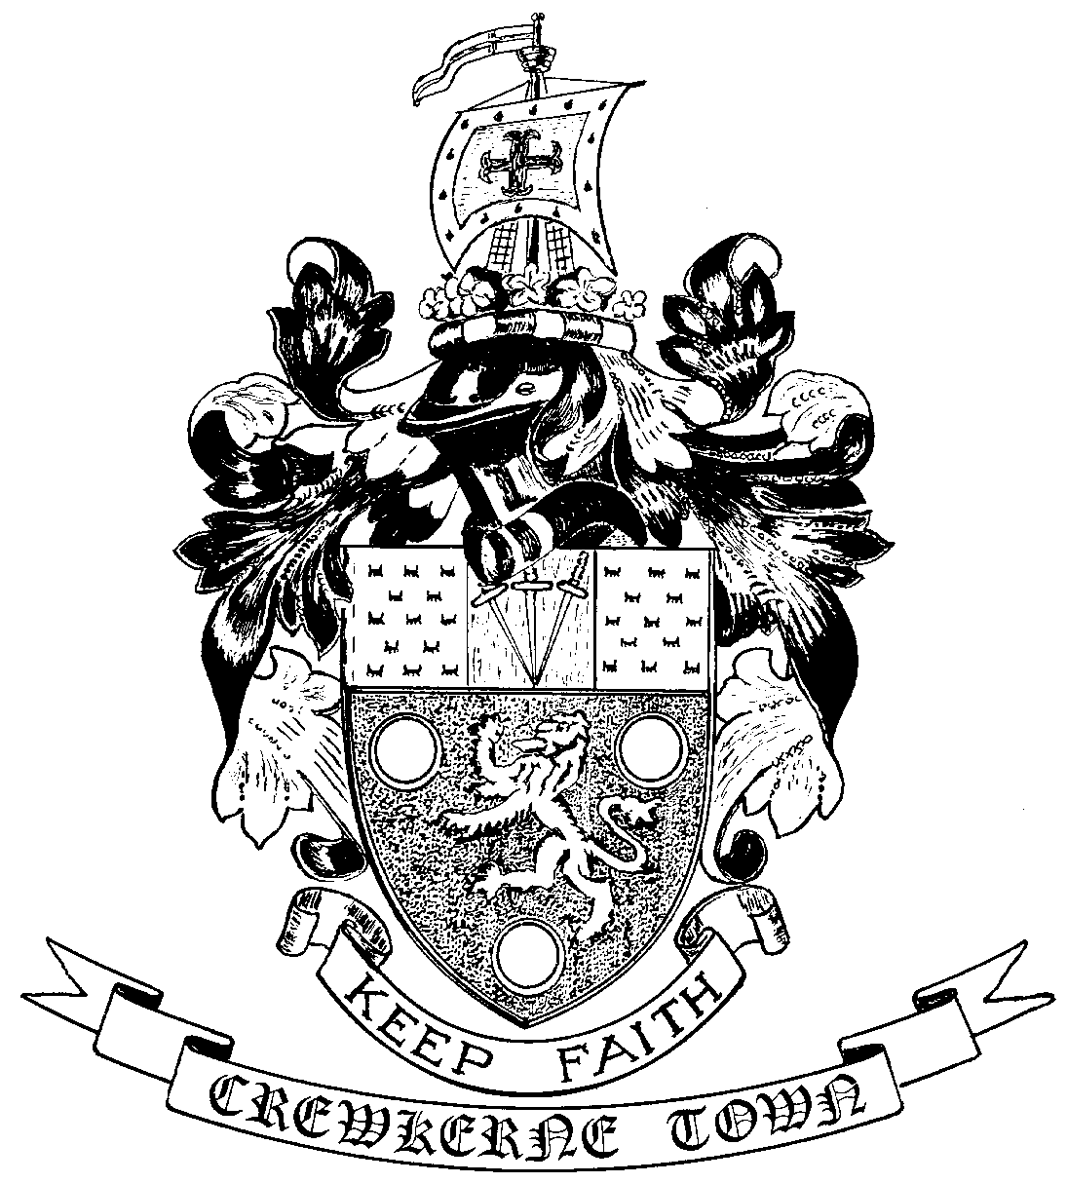

TOWN HALL
MARKET SQUARE
CREWKERNE
SOMERSET TA18 7LN
TEL: 01460 74001
Email: towncouncil@crewkerne-tc.gov.uk

To all Members of the Council
Councillors are hereby summoned, and members of the press and public are invited to attend the next meeting of Crewkerne Town Council, to be held in the Council Chamber, Market Square on
Monday 26 November 2018 at 6.45 pm.

……………………..
Peter Davidson, Town Clerk
20 November 2018

A G E N D A

- To note apologies for absence
- Food festival: to receive a presentation from Eat Festivals on a proposal for a food festival in Crewkerne.
- Open Forum: Questions may be put to the Council during this Public Participation Session of up to 15 minutes and a maximum of 3 minutes per person.
- To confirm the minutes of the Town Council Meeting held on 29 October 2018.
- Declarations of interest in items on the agenda.
- To receive reports from the County and District Councillors.
- Clerk’s progress report: to receive an update report (for information).
- Planning applications: to consider the following applications requiring observations before the next Planning and Highways Committee meeting:
18/02885/FUL: Rotalink Ltd, Cropmead, Crewkerne TA18 7HQ: Alterations, some demolition and the erection of an extension to existing building.
- Finance
- To approve the accounts for payment for November as listed
- To report the bank reconciliation for October has been completed.
- To receive a report from the Clerk on consolidation of Joint Burial Committee accounts into those of the Town Council.
- Internal audit interim report: to receive the report from the internal auditor.
- Use of the GRC kitchen in support of the Youth Service: to consider the additional charge from CSYAL for use of the GRC kitchen in support of the Youth Service.
- Food festival: to consider the proposal for a food festival to be held in July 2019.
- Request for the use of Henhayes: to consider a request from Crewkerne Rugby Club to use Henhayes as the venue for a rugby festival in March 2019.
- Outside body representatives for Chubbs Almshouses: to confirm whether
Cllr. Hodgson wishes to continue as a representative for Chubbs Almshouses and, if not, to appoint an alternative representative.

PTO
- To receive draft Committee and Working Group minutes:
- Policy and Resources Committee meeting held on 29 October 2018.
- Planning and Highways Committee meeting held on 12 November 2018.
- Amenities Committee meeting held on 12 November 2018.
- To receive Matters of Report (for information only).
- Next meeting on Monday 17 December 2018 at 6.45pm in the Council Chamber.

In accordance with the Public Bodies (Admission to Meetings) Act 1960 s 1(2), to resolve that the press and members of the public be excluded from following items having regard to the confidential issues to be discussed.
Confidential Session: Exclusion of the Press & Public - Contractual matter and review of grant applications.

