CREWKERNE TOWN COUNCIL
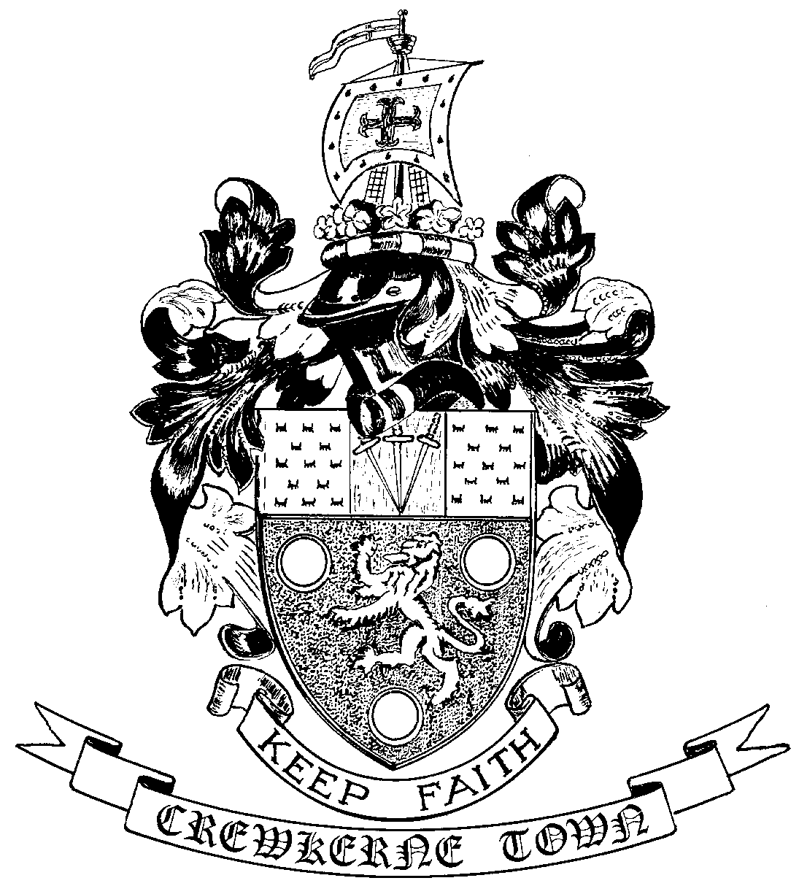

TOWN HALL
MARKET SQUARE
CREWKERNE
SOMERSET TA18 7LN
TEL: 01460 74001

Town Clerk: Email – towncouncil@crewkerne-tc.gov.uk
Mr P Davidson

Councillors are hereby summoned and members of the press and public are invited to attend the next meeting of the Amenities Committee of Crewkerne Town Council to be held in the Council Chambers, Town Hall, Market Square on Monday 12 November 2018 after the Planning and Highways Committee meeting and commencing not before 7pm.

Peter Davidson, Town Clerk
6 November 2018

AGENDA
- To note apologies for absence
- Open Forum: questions may be put to the Committee during this Public Participation Session of up to 15 minutes and a maximum of 3 minutes per person.
- To approve the minutes of the previous meeting on 10 September 2018.
- Declarations of interest in items on the agenda.
- Project and Works report: to receive the November 2018 report.
- Barn Street recreation ground
- To consider rescinding the current “no dogs” policy.
- To consider the purchase of new and replacement facilities.
- Badgers at Happy Valley
- to consider the next steps in ensuring that badgers do not encroach on the sandpit play area.
- To consider the wider issue of the damage being caused by badgers at Happy Valley and whether there are options to address the issue.
- Circular path at Henhayes: to further consider a proposal from ABCD for a circular path around Henhayes recreation ground.
- Hanging baskets and bedding plants: to approve expenditure for summer hanging baskets and bedding plants.
- Christmas lights for Market Street: to approve the purchase of a set of replacement Christmas lights for a section of the west side of Market Street.
- Correspondence: to consider correspondence received from the Henhayes Centre regarding banners on the Lucombe oak fencing.
- To receive Sub-Committee minutes and working group notes
- Bincombe Management Committee meetings held on 6 November 2018.
- Aqua Centre Bi-monthly meeting held on 5 November 2018.
- GRC Bi-monthly meeting held on 17 September 2018.
- To receive any Matters of Report (for information only)
- Next meeting: 14 January 2019 after the Planning & Highways Committee meeting.

