CREWKERNE TOWN COUNCIL
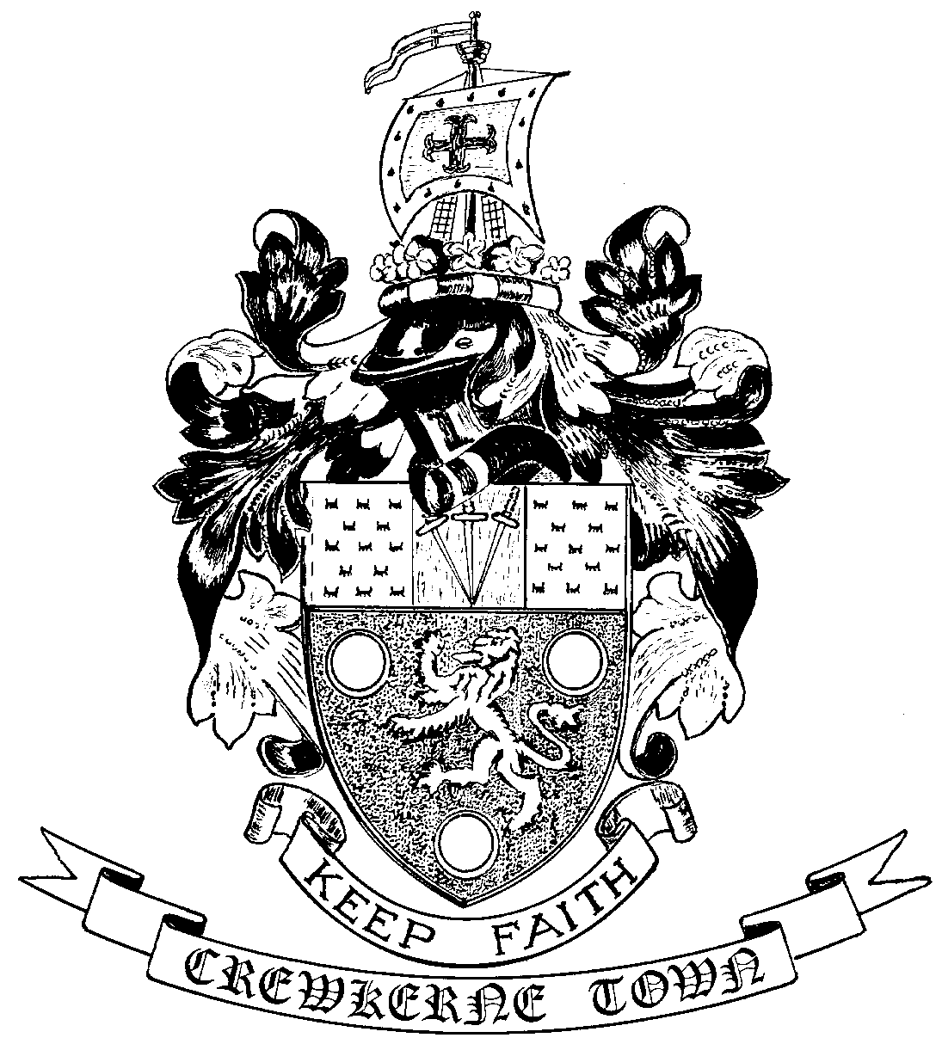

TOWN HALL
MARKET SQUARE
CREWKERNE
SOMERSET TA18 7LN
TEL: 01460 74001
Email: towncouncil@crewkerne-tc.gov.uk

Councillors are hereby summoned and members of the press and public are invited to attend the next meeting of Crewkerne Town Council, to be held in the Council Chambers, Market Square on Monday 28 November 2016 at 6.45 pm.

……………………..
Peter Davidson, Town Clerk
22 November 2016
A G E N D A

- To note apologies for absence
- Open Forum: Questions may be put to the Council during this Public Participation Session of up to 15 minutes and a maximum of 3 minutes per person.
- To confirm the minutes of the Town Council Meetings held on 24 October and 14 November 2016.
- Declarations of interest in items on the agenda.
- To receive reports from the County and District Councillors.
- Clerk’s progress report: to receive an update report (for information).
- Deferred items
- New Town Council website: WordPress website development software has now been upgraded, which now allows Cllr Miss Pritchard to refine the prototype website. Ongoing.
- Planning applications: to consider the following applications requiring observations before the next Planning and Highways Committee meeting:
16/04479/FUL: 66 Hermitage Street, Crewkerne. Alterations, change of use and conversion of shop to single storey dwelling (Additional information).
16/04720/LBC: IPS Palace, 145 South Street, Crewkerne. Internal and external alterations to include the installation of extraction/ventilation equipment (Revised Application).
- Finance
- To approve the accounts for payment for November as listed
- To report the bank reconciliation for October has been completed.
- Quality Council: to receive a progress report from the working group on the route to achieve accreditation in the Local Council Award Scheme at “Quality” level.
- Outside Body representation : to appoint a new Town Council representative for the Crewkerne Area Business Chamber
- Newsletter delivery: to consider the acceptability of the newsletter being delivered alongside advertising material.
- To receive draft Committee and Working Group minutes:
- Planning and Highways Committee meeting held on 14 November 2016
- Amenities Committee meeting held on 14 November 2016
- Outside Bodies: to receive reports for Crewkerne Voluntary Transport and CAD.
- To receive Matters of Report (for information only)
- Next meeting on Monday 19 December 2016 at 6.45pm in the Council Chamber.

In accordance with the Public Bodies (Admission to Meetings) Act 1960 s 1(2), to resolve that the press and members of the public be excluded from following items having regard to the confidential issues to be discussed.
Confidential Session: Exclusion of the Press & Public - Contractual Matters

